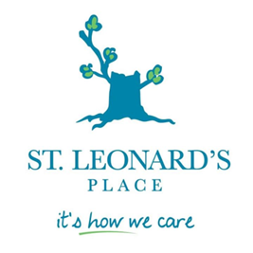
HOUSING ACCESS RETENTION PROGRAM REFERRAL FORM

Last Name: | Agency Name:
First Name: | Agency Contact:
Last Known Address: | Agency Phone No.
Cell Phone: | Position/Title:
Email address: | Signature:
 | Email:
Notes

ELIGIBILITY REQUIREMENTS:
- Homeless Adult Male (21 years and older). ‘And”
- Homeless Adult Male (Discharged from Hospital). ‘OR’
- Homeless Adult Male (In Conflict with the Law).’OR”
- Homeless Adult Male (Involved with the Criminal Justice System)

BARRIES TO HOUSING:
- Experiencing chronic or episodic homelessness
- Medical Diagnosis of Mental Health Illness or Mental Health Related Illnesses.
- Ontario Works or Ontario Disability Support Program as a Source of Income.
- Substance and Addiction Issues.
- Currently resides in the Region of Peel.

If you have any questions or inquiries regarding the program please contact our HARP Care Coordinator at PH: 905-457-3611 Ext. 294|Fax: 905-457-2314|Email: donnap@slpp.ca (Brampton) or sharaayneh@slpp.ca (Mississauga) |Web: www.stleonardsplace.com.

